

**FACULTY OF INFORMATION TECHNOLOGY**

**DEPARTMENT OF INFORMATION MANAGEMENT**

**INTERNSHIP REPORT CARRIED OUT AT**

**EXUUS LTD**

**Prepared by HIRWA Dieume #17410**

**Kigali, December 2016**

**DECLARATION**

I, HIRWA Dieume, a student of Information Management at Adventist University of central Africa (AUCA) registered under #17410, Hereby declare that the company training presented in this dissertation is my original work and has never been presented at any university or institution where other people’s work has been used, references have been provided and in some cases quotations made. The contents of this document are the result of my own effort and to the best of my knowledge has not been committed in whole or part of any other university and not in any other institution.

HIRWA Dieume

Signature: …………………………….

Date: ……...…/……../……….;

**DEDICATIONS**

This report is dedicated:

* To the Almighty God.
* To my beloved parents and relatives.
* To EXUUS ltd who gave me all the support I needed.
* To AUCA staff who supported me throughout my studies and during my internship.
* To my friends and colleagues at AUCA.

**APPROVAL**

This is to certify that HIRWA Dieume did his company training at EXUUS ltd from 08th August 2016 to 07th October 2016. He has been under my supervision and has successfully finished his training. His report is now ready for submission to the IT department, Adventist University of Central Africa (AUCA).

Company Supervisor

Signature……………………………………………………………………

Name……………………………………………………………………….

Date ………………………………………………………………………..

# **ACKNOWLEDGEMENT**

The internship opportunity I had with **EXUUS LTD** was a great chance for learning and professional development. Therefore, I consider myself as a very lucky individual as I was provided with an opportunity to be a part of it. I am also grateful for having a chance to meet wonderful people and professionals who led me though this internship period.

First I would like to thank **Mr. SHEMA Steve**, CEO of EXUUS ltd for giving me the opportunity to do an internship within the organization. For me it was a great pleasure to get this opportunity.

I also would like to express my deepest gratitude and special thanks to my supervisor, the CTO of EXUUS ltd **Mr. MUHIRE Jean Remy** who in spite of being busy with his duties, took time out to hear, guide and keep me on the correct path to achieve more during the period of my internship.

At last I would like to thank all my colleagues listing TUYISHIME Jean Luc, RUTAMU Belyse, UMUTONI Amanda who have been helping and comprehensive fellows.

May the Lord Almighty Bless you all abundantly!!!

# ABSTRACT

Generally, this industrial training report provides information on the background, mission, objectives of EXUUS ltd.Therefore it can be used as a source of information for anyone who is interested in knowing information concerning EXUUS ltd.

My industrial training at EXUUS ltd lasted for nine weeks, from 08th August to 08th October 2016. It helped me to relate the theories gained in class with practice in order to gain hands on experience in real work environment and introduce myself to the professional career. During my internship period a number of approaches and exposure methods were used to collect the required information about different skills applied in EXUUS ltd. Among these there is observation, participatory approach, reading relevant materials, and also questions and answer approaches in order to achieve the intended objectives.

This document has different parts. Chapter one comprises , the general introduction, objectives, significance of internship, the reason of choosing EXUUS ltd as training site, pre request for industrial training , chapter two comprises organizational profile, its mission, vision . Chapter three comprises field attachment activities and the fourth chapter comprises appreciation, conclusion and recommendation.

**LIST OF TABLES**

Table 1: Table of User description

Table 2: Table of Group description

Table 3: Table of Menu description

Table 4: Table of Sharings description

Table 5: Table of Cover description

**LIST OF FIGURES**

Figure 1: EXUUS Logo

Figure 2: Ubuntu 16.10 Screenshot

Figure 3: Windows Boot Manager interface to let you choose between Windows and Ubuntu

Figure 4: Ubuntu OS login screen

Figure 5: Ubuntu Default Desktop environment

Figure 6: Ubuntu Interface Component

Figure 7: Ubuntu Software Center

Figure 8: Code to install VLC Media player

Figure 9: Command of installing git in terminal

Figure 10: Adding and committing changes with git

Figure 11: git pull for pulling from the server

Figure 12: Lunchex Homepage

Figure 13: Lunchex Shared menu on web

Figure 14: List of created menus by an active user

Figure 15: Confirming attendance interface

Figure 16: Creating menu interface

Figure 17: Android Sign up interface

Figure 18: Android shared enu, create group and create menu interface

Figure 19: Android Interface to confirm

Figure 20: Interface of groups a user belongs to

Figure 21: Model.py file

Figure 22: Schema.py file

Figure 23: GET method APIs

Figure 24: HTTP GET method request

Figure 25: Result of query in a JSON format

Figure 26: POST method APIs

Figure 27: HTTP POST method request

Figure 28: Result of posted data in JSON format

Figure 29: PUSH method APIs for updating

Figure 30: DELETE methof APIs for deleting

**CHAPTER ONE: INTRODUCTION**

**1.0. General introduction**

Internship is one of the University courses scheduled in its academic program to be undertaken by finishing their academic cycle. It is a practical course intended to equip the student acquainted with practical knowledge in his respective field of study. The training is set to prepare the final year students to have the global picture of how practical work is done from the view point of the field.

This training is of vital importance in accordance with real and professional applications of the concerned information technology and software principles and techniques.

It addresses to the concerned student the way how theories studied in classrooms are feasibly applied on the field, and hence offering him a conclusive orientation on how to practically do things thus preparing for future employment.

In the due course, the intern makes an assessment on the organization under study. In addition, the study and ultimate report by the student, ushers in more advantage towards the accomplishment of his University and thus, the award of a bachelor’s degree in the resultant end.

**1.1. Objectives** **of** **internship**

**1.1.1. General objective**

Its major aim is to put into practice what were learnt in class theoretically by applying them in the field so as to become a professional worker who is familiar with all the required skill in the working environment.

***1.1.2 Specific objectives***

* To prepare students for the award of degrees of four years in AUCA.
* To increase a student's sense of responsibility.
* To study the working process and procedure of the organization ( RRA)
* To improve knowledge and qualification as an IT professional
* To gain interpersonal skills and promote personal growth and development

# 1.2. Significance of internship

So far most of the studies have been thought theoretically, which could lead to a biased knowledge if they are not put into practices. Therefore internship is a basic element that links a student to the practical skills. Majorly student starts with academic internship to gain practical

Knowledge and experiences, without industrial attachment a graduate could be misled in the professional careers.

# 1.3. EXUUS ltd choice for internship

The selection of the site makes a strong first step when one looks at the target of the internship. If a poor choice is made on where to do internship from, the main target will not be achieved. EXUUS ltd is one of the organizations where by IT skills can be gained professionally that is the reason why I chose it so that I can achieve my objectives. EXUUS ltd has got qualified professionals who can train someone to get the required skills alongside their efficient and new technologies.

# 1.4. Pre request for this industrial training

This industrial training required a trainee who have strong background in IT and Software development, these include knowledge in different programming languages, database management systems, system administration, and networking as well as other courses offered IT and Software Engineering.

**CHAPTER TWO: OVERVIEW OF EXUUS ltd.**

# 2.1. EXUUS ltd logo



Fig 1: EXUUS ltd Logo

# ****2.2. EXUUS ltd vision****

Exuus Ltd is a limited liability IT Company based and incorporated in Rwanda under Rwanda’s company law with the following vision statement:

*“Inspiring and enabling businesses to achieve their optimal satisfaction by positively impacting the future through a deeper strategic, geographic and environmental friendly understanding of the changing world around them.”*

# ****2.3.** EXUUS ltd **mission****

“*With our value proposition found in the framework of both ICT & GIS, We will endeavor to create products that are ideal in every possible way, products that excite, easy to use, cost-effective and powerful.*”

We plan to achieve our mission by redefining how data (big & small) visualization in time and space can be efficiently optimized in sync with ICT tools. In simple terms you would say marrying GIS (Geographic Information System) to ICT (Information and Communications Technology).

**2.4. Company’s Objectives**

Along with the aforementioned vision and mission we have identified the following objectives that are threefold and set to be achieved with 5 years time:

- Pioneer of SAR

Introduce Synthetic Aperture Radar data application on the Rwandan and East African market

- Big Data

To redefine the collection, analysis and use of big data by optimizing the synergies between ICT and GIS tools (Geographic Information System)

- Enterprise Solution

Become the leading enterprise solutions provider in Rwanda for data management systems by committing to deliver excellence in business performance while focusing on efficiency and simplicity

# CHAPTER THREE: FIELD ATTACHMENTS ACTIVITIES

# PART ONE: UBUNTU OS

# 3.1.1. Introduction to UBUNTU OS

In this part I gained a better understanding of UBUNTU OS which is a free/libre, open-source computer operating system with 20 million users worldwide. But it’s also so much more than that: it is an ethos, a collaborative project and, first and foremost, Ubuntu is a community of people.

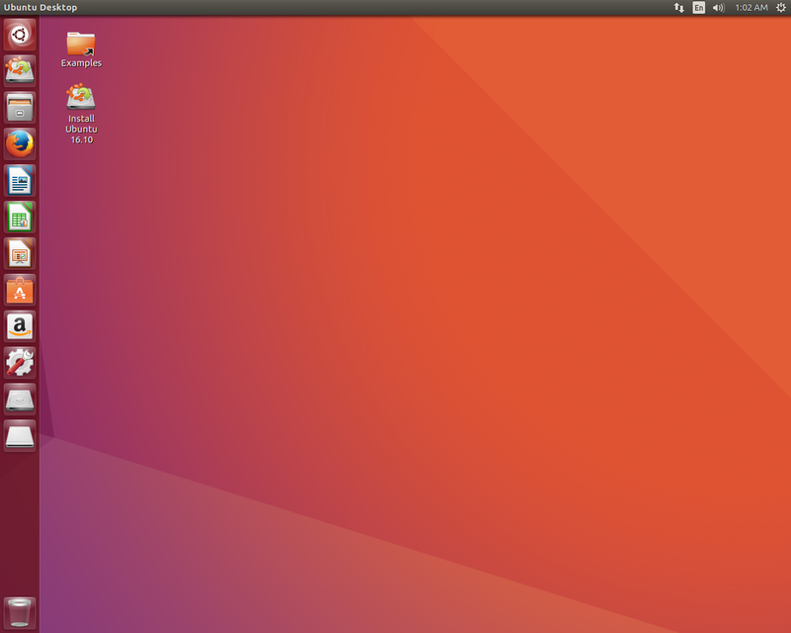

fig 2: Screenshot of ubuntu 16.10

3.1.2. Understanding what an OS is?

In simplest terms, an operating system, or OS, is software that communicates with computer hardware.

An operating system (OS) is the program that, after being initially loaded into the computer by a boot program, manages all the other programs in a computer. The other programs are called *applications* or application programs. The application programs make use of the operating system by making requests for services through a defined application program interface ([API](http://searchexchange.techtarget.com/definition/application-program-interface)). In addition, users can interact directly with the operating system through a user interface such as a command line or a graphical user interface ([GUI](http://searchwindevelopment.techtarget.com/definition/GUI)).

Examples:

Windows , Mac OS, Linux-Based: Ubuntu, Kali, Mint, Redhat.

3.1.3. Understanding UBUNTU

Ubuntu is many things, but it is most famous for being a computer operating system.

3.1.3.1. What is FLOSS?

FLOSS is the acronym for Free/Libre Open-Source Software. FLOSS software is different from proprietary or commercial software because it is:

• FREE to use

• FREE to share, and

• FREE to develop

This means you can download and use Ubuntu without paying money. You can then make copies of the software and distribute it to as many people as you want. Finally, the source code of Ubuntu’s operating system is freely available, so you can inspect the program and make changes to suit your own needs.

3.1.3.2. What Is The Linux Kernel?

A kernel is the core component of any operating system and acts as the mediator between software and hardware. A kernel, on its own, is not an operating system, but rather a set of computer instructions that enable communication between software applications and the data processing done at the hardware level.

The Linux kernel is used in man y FLOSS operating systems and, just like Ubuntu, is released under the GNU General Public License. It is called ‘Linux’ because it is named after Linus Torvalds, the Finnish computer programmer who created it in 1991.

3.1.3.3 How Then Are Ubuntu & Linux Related?

Ubuntu is a FLOSS operating system that uses the Linux kernel. Put simply, Linux is one part of Ubuntu, which is made of many different parts.

3.1.3.4. Why Use Ubuntu?

There are many reasons to use Ubuntu, but here are some of the most important ones:

• It’s free and open source: shared code, shared efforts, shared principles, no cost.

• It’s easy to use, trial and install: you don’t have to be an expert.

• It’s beautiful, sleek, and stylish

• It’s stable and fast: usually loads in less than a minute on modern computers.

• It has no major viruses! Ubuntu is immune to computer-crashing Windows viruses. Say goodbye to Blue Screens of Death!

• It’s up-to-date: Canonical releases new versions of Ubuntu every six months and also brings you regular updates for free.

3.1.4. Installing Ubuntu

3.1.4.1 Different Ways To Install Ubuntu

There are three different ways you can install Ubuntu on to your computer:

* Download & Install It

This option will replace your current operating system with Ubuntu. A complete installation will run the fastest and smoothest on your computer, but requires a full commitment to leave behind your old operating system.

For step-by-step instructions on how to do this, please visit:

<http://www.ubuntu.com/download/ubuntu/download>

Note that this method can also be used to create a dual-boot setup, but requires some knowledge of partitioning. Keep reading for an easier method.

* Try It On A CD Or USB Stick

This option will allow you to maintain your current operating system and also run Ubuntu from an independent storage device. This installation requires the least commitment from you and your computer, but will probably affect the quality and speed of Ubuntu’s performance.

For step-by-step instructions on how to do this, please visit:

<http://www.ubuntu.com/download/ubuntu/download>

* Run It Alongside Windows Or Mac OS

This option, also known as a dual boot installation, will install Ubuntu on your computer alongside your current Windows or Mac operating system. Whenever you start your computer, you will have the option of choosing to boot into Ubuntu or Windows/Mac OS.

This is the installation option that we will be discussing in this guide as it is the easiest way for beginners to transition to Ubuntu. Detailed instructions will be provided for a Windows 7 dual boot.

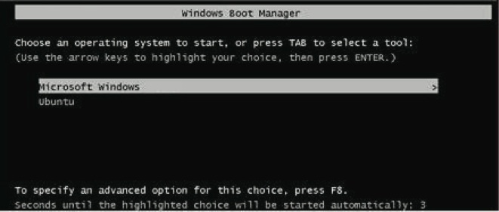

Fig 3: A screenshot of Windows Boot Manager giving you options to choose between Windows and Ubuntu.

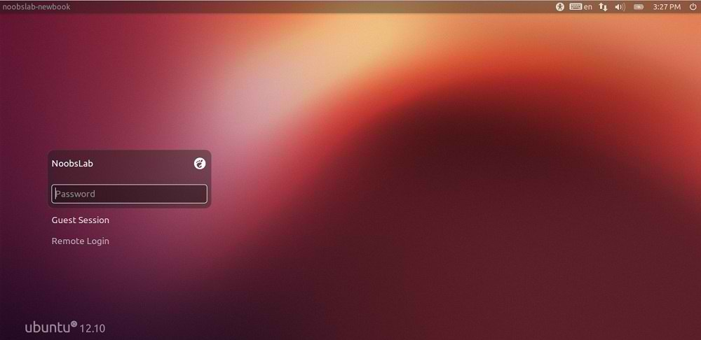

Fig 4: Ubuntu login Screen

3.1.5. Getting Started With Ubuntu

After successfully installing Ubuntu and logged in for the first time, you should be greeted with a screen that looks something like this:

fig 5: Ubuntu’s Default Desktop Environment

3.1.5.1 What Is Unity?

Unity is Ubuntu’s default desktop environment. In simplest terms, it is what you see when you log-in to Ubuntu. It is within Unity that you can drag, drop, and click on various icons and menus to interact with the Ubuntu operating system.

3.1.5.2 The Unity Interface

The Unity interface is made up of four main components:

• Desktop

• Launcher

• Panel

• Dash (accessed by the Ubuntu button)

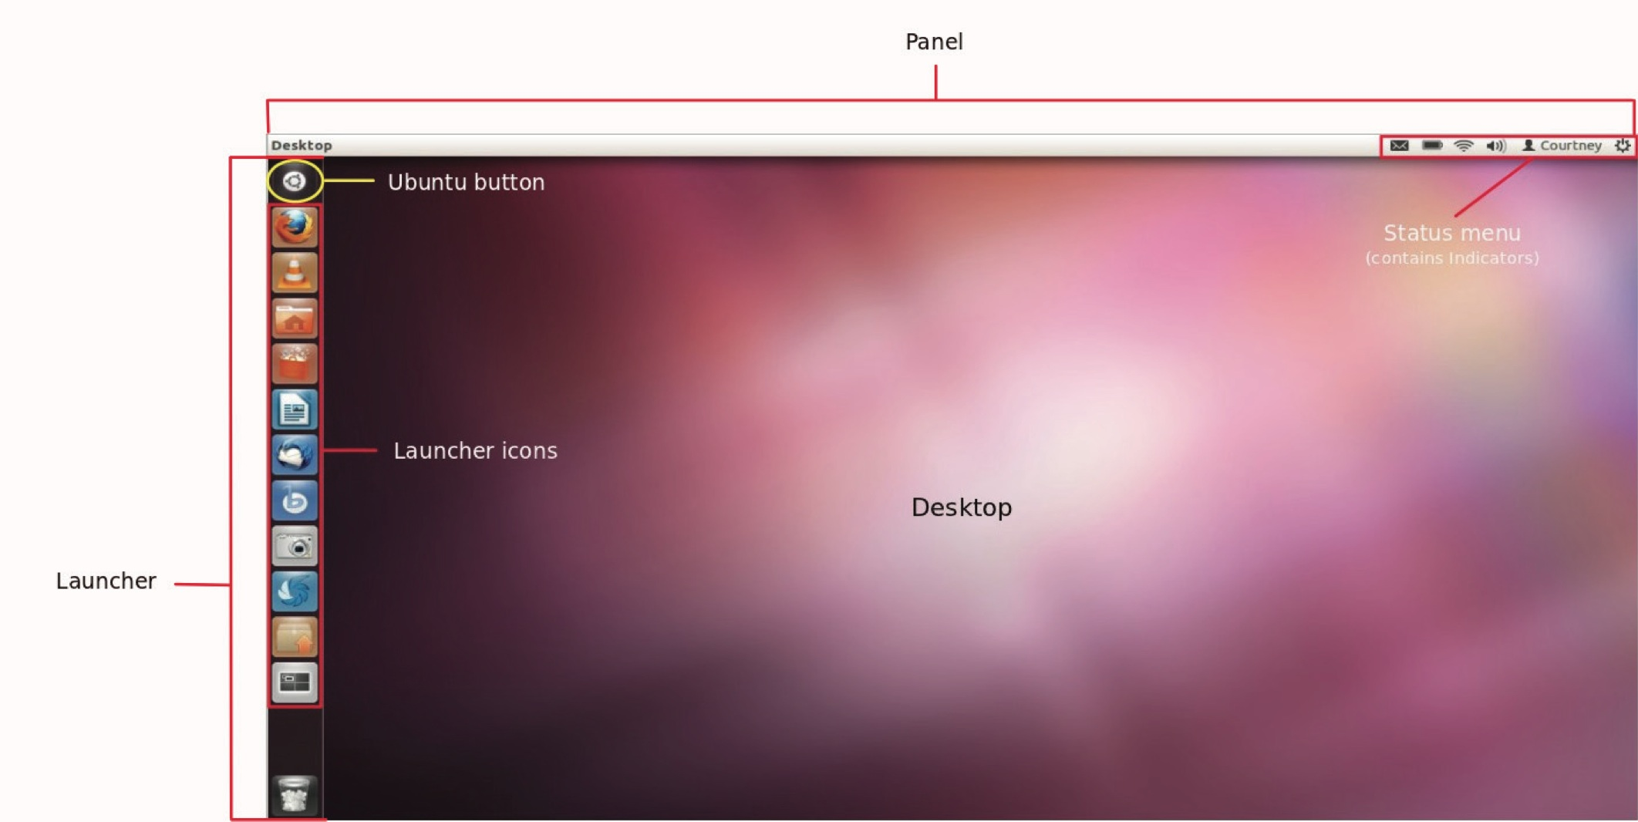

fig 6: Ubuntu Interface Components

3.1.6. Ubuntu Applications (How Do I…?)

Now that you’ve got a handle on the Unity desktop environment, the next step of your journey is to start using Ubuntu compatible programs and applications. If you’ve recently migrated from a proprietary operating system, you might not be aware of what is available and what programs should you use.

3.1.6.1.How Do I Update My Computer?

You’ve done the work of installing Ubuntu on to your computer, and now you need to make sure your system is safe, secure, and up-to-date by using the Update Manager. This program will start itself regularly, and you can use it to:

• install security updates and critical bug fixes for all your software

• manage the frequency and automation of updates

• manage software sources

• download and install the latest version of Ubuntu

3.1.6.2.How Do I Download Software & Applications?

Are you not sure which software programs are compatible with Ubuntu? Do you want a central application that will manage all of your software needs? Then look no further than Ubuntu Software Center (USC), an application that allows you to download, install, and remove software in a single window without ever having to launch an Internet browser.

* Ubuntu Software Center is accessible through your Launcher as well as the Dash. Use USC to discover thousands of FREE applications, games, fonts, and other software that has been tested and validated to work seamlessly with Ubuntu.

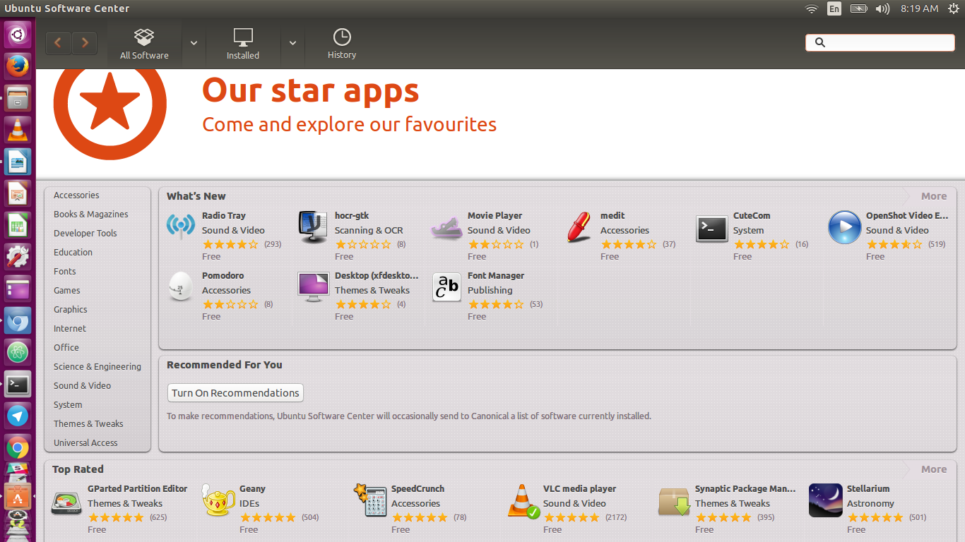Fig 7: Ubuntu Software Center

With Ubuntu Software Center, you can:

• search for, download, install, and remove software in a single window

• keep track of installation, update and removal history

• test-drive software without installation or purchase

• read and write user reviews

• receive software recommendations based on your search and installation history

• filter software searches by providers, like Ubuntu, Canonical Partners, and For Purchase

• manage payment information and transaction history with a single Ubuntu account

* + - Installing Application using Package in Ubuntu from Internet

If you have been using Ubuntu for a you know that every Linux distros has its own package management system (containing software list). For Ubuntu, it is Advanced Packaging Tool (APT). In Ubuntu, it has a list of repositories of the software package which are available and act as a database of all package sources. Installing software using APT is very easy, but you need the internet to download the file.

For example if you want to install VLC media player:

To Install VLC in Ubuntu

Open a terminal(ctrl+alt+t) and run the following commands. Just copy and paste it in the terminal, Issue the password for the user when prompted.

First update your repository to install the latest version.

sudo apt-get update

after updating use the below command.

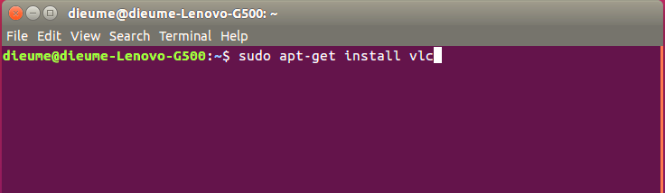Fig 8: Code to install VLC Media player through Terminal.

A list of Applications which you can Use in Ubuntu to do different activities:

* + - Create Documents, Spreadsheets & Presentations: LIBRE OFFICE 5.
    - Listen to Music : vlc, rythmbox,
    - Play Video: vlc, videos, ..
    - Surf on Web : mozilla firefox, chromium,
    - Viewing Photos: Shotwell Photo Manager
    - Manage Social Media Accounts: Gwibber

**PART II: GIT**

**3.2. Using GIT:**

Git has exploded in popularity in recent years. The version control system is used by huge open source projects like Linux with thousands of contributors, teams of various sizes, solo developers and even students.

### The basics

Git is a collection of command line utilities that track and record changes in files (most often source code, but you can track anything you wish). With it you can restore old versions of your project, compare, analyze, merge changes and more. This process is referred to as version control. There are a number of version control systems that do this job like – SVN, Mercurial, Perforce, CVS, Bitkeeper and more.

Git is decentralized, which means that it doesn’t depend on a central server to keep old versions of your files. Instead it works fully locally by storing this data as a folder on your hard drive, which we call a repository. However you can store a copy of your repository online, which makes it easy for multiple people to collaborate and work on the same code. This is what websites like Github and BitBucket are used for.

#### 3.2.1. Installing Git

Installing Git on your machine is straightforward:

* Linux – Simply open up a new terminal and install git via your distribution’s package manager. For Ubuntu the command is: sudo apt-get install git
* Windows – we recommend [git for window](https://git-for-windows.github.io/)s as it offers both a GUI client and a BASH comand line emulator.
* OS X – The easiest way is to install homebrew, and then just run brew install git from your terminal.

As I use Linux Ubuntu, I wll install using **sudo apt-get install git.**

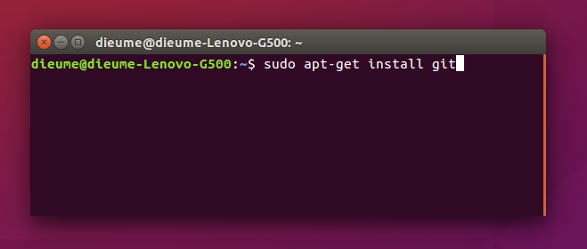

Fig 9: Command of installing git in terminal.

#### **3.2.2. Creating a new repository – git init**

As mentioned earlier, git stores its files and history directly as a folder in a project. To set up a new repository, we need to open a terminal, navigate to our project directory and run **git init**.

This will enable Git for this particular folder and create a hidden .git directory where the repository history and configuration will be stored.

You create a folder on your Desktop called git_exercise, open a new terminal and enter the following:

**$ cd Desktop/git_exercise/**

**$ git init**

The command line should respond with something along the lines of:

Initialized empty Git repository in /home/user/Desktop/git_exercise/.git/

This means that our repo has been successfully created but is still empty. Now create a simple text file called hello.txt and save it in the git_exercise folder.

#### **3.2.3. Checking the status – git status**

Git status is another must-know command that returns information about the current state of the repository: is everything up to date, what’s new, what’s changed, and so on. Running

**git status** in our newly created repo should return the following:

$ git status

On branch master

Initial commit

Untracked files:

(use "git add ..." to include in what will be committed)

hello.txt

The returned message states that hello.txt is untracked. This means that the file is new and Git doesn’t know yet if it should keep track of the changes happening to that file or just ignore it. To acknowledge the new file, we need to stage it.

#### **3.2.4. Staging – git add**

Git has the concept of a “staging area”. You can think of this like a blank canvas, which holds the changes which you would like to commit. It starts out empty, but you can add files to it (or even single lines and parts of files) with the git add command, and finally commit everything (create a snapshot) with git commit.

In our case we have only one file so let’s add that:

$ git add hello.txt

If we want to add everything in the directory, we can use:

$ git add -A

Checking the status again should return a different response from before.

$ git status

On branch master

Initial commit

Changes to be committed:

(use "git rm --cached ..." to unstage)

new file: hello.txt

Our file is ready to be commited. The status message also tells us what has changed about the files in the staging area – in this case its *new file*, but it can be *modified* or *deleted*, depending on what has happened to a file since the last git add.

#### 3.2.5. Commiting – git commit

A commit represents the state of our repository at a given point in time. It’s like a snapshot, which we can go back to and see how thing were when we took it.

To create a new commit we need to have at least one change added to the staging area (we just did that with git add) and run the following:

$ git commit -m "Initial commit**."**

This will create a new commit with all the changes from the staging area (adding hello.txt). The -m "Initial commmit" part is a custom user-written description that summarizes the changes done in that commit. It is considered a good practice to commit often and always write meaningful commit messages.

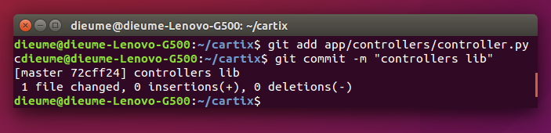

Fig 10: A screensshot of adding and committing changes with git.

**3.2.6. Remote repositories**

Now we go to remote repositories which are on web-based Git repository hosting service. Here, we will be using GITHUB.

**GitHub** is a web-based Git repository hosting service. It offers all of the distributated version control and Source code management SCM) functionality of Git as well as adding its own features. It provides access control and several collaboration features such as [bug tracking](https://en.wikipedia.org/wiki/Bug_tracking_system), [feature requests](https://en.wikipedia.org/wiki/Software_feature), [task management](https://en.wikipedia.org/wiki/Task_management), and wikis for every project.

GitHub offers both plans for private [repositories](https://en.wikipedia.org/wiki/Repository_(version_control)), and free repositories on the same account which are commonly used to host open-source oftware projects. As of April 2016, GitHub reports having more than 14 million users and more than 35 million repositories, making it the largest host of source code in the world.

#### **3.2.7. Connecting to a remote repository – git remote add**

In order to upload something to a remote repo, we first have to establish a connection with it. For the sake of this tutorial our repository’s address will be <https://github.com/dhirwa/Cartix-Redesign> . We advise you to go ahead and create your own empty repository at GitHub or any other service. The registration and setup may take a while, but all services offer good step-by-step guides to help you.

To link our local repository with the one on GitHub, we execute the following line in the terminal:

# This is only an example. Replace the URI with your own repository address.

**$ git remote add origin https://github.com/dhirwa/Cartix-Redesign.git**

A project may have many remote repositories at the same time. To be able to tell them apart we give them different names. Traditionally the main remote repository in git is called *origin*.

#### 3.2.8. Uploading to a server –git push

Now it’s time to transfer our local commits to the server. This process is called a push, and is done every time we want to update the remote repository.

The Git command to do this is git push and takes two parameters – the name of the remote repo (we called ours origin) and the branch to push to (master is the default branch for every repo).

**$ git push origin master**

Counting objects: 3, done.

Writing objects: 100% (3/3), 212 bytes | 0 bytes/s, done.

Total 3 (delta 0), reused 0 (delta 0)

To https://github.com/dhirwa/Cartix-Redesign.git

* [new branch] master -> master

**3.2.9. Cloning a repository –git clone**

At this point, people can see and browse through your remote repository on Github. They can download it locally and have a fully working copy of your project with the git clone command:

$ git clone https://github.com/dhirwa/Cartix-Redesign.git

A new local respository is automatically created, with the github version configured as a remote.

#### 3.2.10. Getting changes from a server –git pull

If you make updates to your repository, people can download your changes with a single command –pull:

**$ git pull origin master**

From https://github.com/dhirwa/Cartix-Redesign

* branch master -> FETCH_HEAD

Already up-to-date.

Since nobody else has commited since we cloned, there weren’t any changes to download.

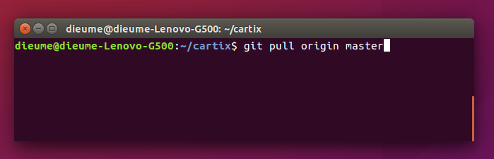 Fig 11: A screenshot of pulling from the server

**PART III: LUNCHEX APPLICATION DEVELOPMENT**

**3.3.1. Introduction**

Lunchex is an application that was thought to help mainly restaurants and some institutions which feed their employees in terms of lunch to share menus. First let's talk about restaurants, on Lunchex a restaurant creates its account and then after creating an account it creates its group and adds other people on the platform and on a daily basis the restaurant shares its menu, so that people can see what they should expect from it on that specific day. About institutions, Imagine this scenario where an institution whose employees share lunch at job , by this I mean they all eat from work and they have a cooker at work who prepares food; The institution has let's say 20 employees, an institution like this creates its group on the platform and adds all of its employees on the group and then on a daily basis, the group admin shares the menu of the day and people on the group (employees) confirm if they will have lunch from there or not and this helps to know what number of people to prepare for and economically it helps the organization.

Lunchex was designed to be a web-based and android application which means that the web and android all had the same back-end; My contribution on this application was the back-end part but also brainstorming with others on functionalities, interfaces, databases and so on.

**3.3.2. Panning the project**

Every project must have a plan, looking the inputs , developments and related problems.

Lunchex is a project that was to be developed by the development team of EXUUS , after analyzing the idea and related problems, Lunchex was planned to be developed in 3 months.

**3.3.3. Requirements**

As we know, project requirements are those functionalities that a project mush have in order to fulfill the users' needs from it. Requirements are got from different stakeholders.

Lunchex requirements gathering was done by the development, getting information from different people, restaurants, users and brainstorming sessions of the team itself.

After all these, these were the requirements that we came up with:

* Sign up (Account creation)
* Sign in
* create menu with its image
* share menu
* daily menu view
* view timeline of menus
* create group
* add members to group
* remove member from group
* view group members
* confirm and cancel attendance
* recovering password

**3.3.4 Lunchex Design**

3.3.4.1 Front-End Development

As I mentioned above, Lunchex is a web and android based application which means that when we thought to develop it we had first to do a mock up of interfaces which should be developed. Obviously, the web app had its interfaces and the android app had its interfaces but both related, understable, user-friendly and integrable to the back-end. My contirbution here was brainstorming with others and giving ideas on how the user interfaces can be simple to use and how to improve to the user experience.

3.3.4.1.1 Web app Interface

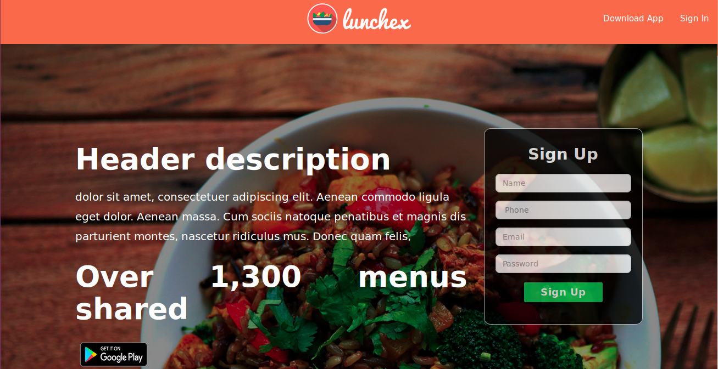

Fig 12: A screenshot of the homepage

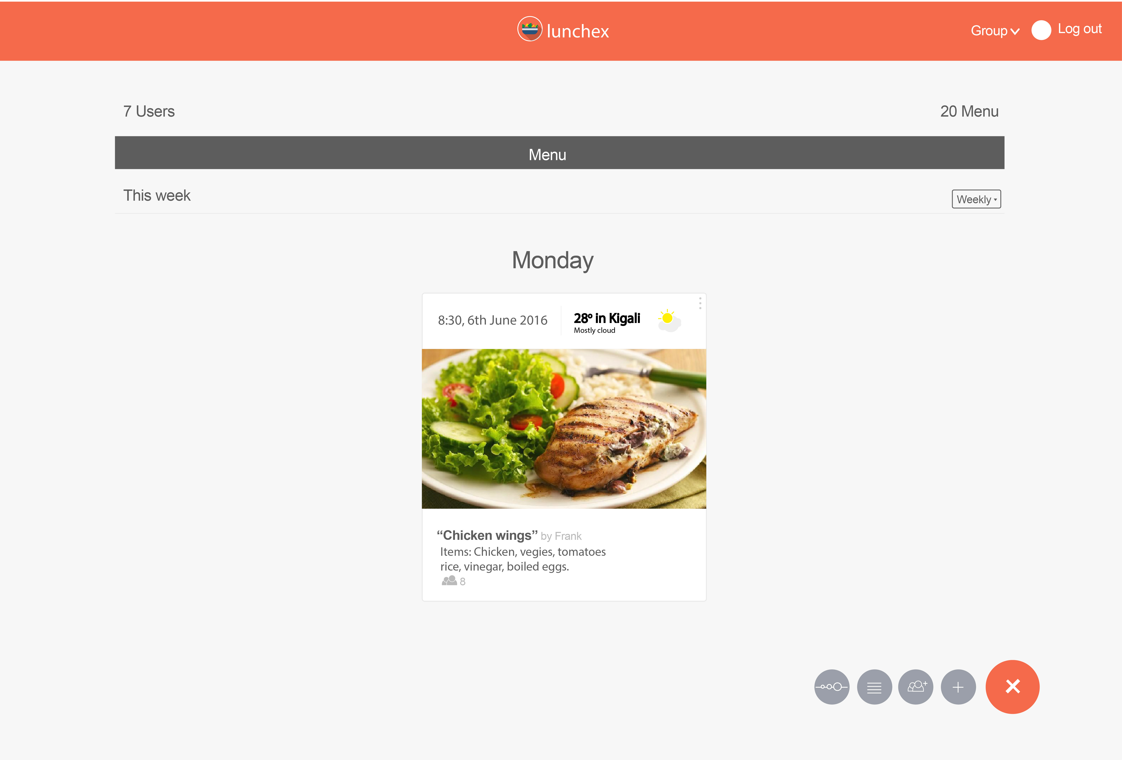

Fig 13: A screenshot of a shared menu.

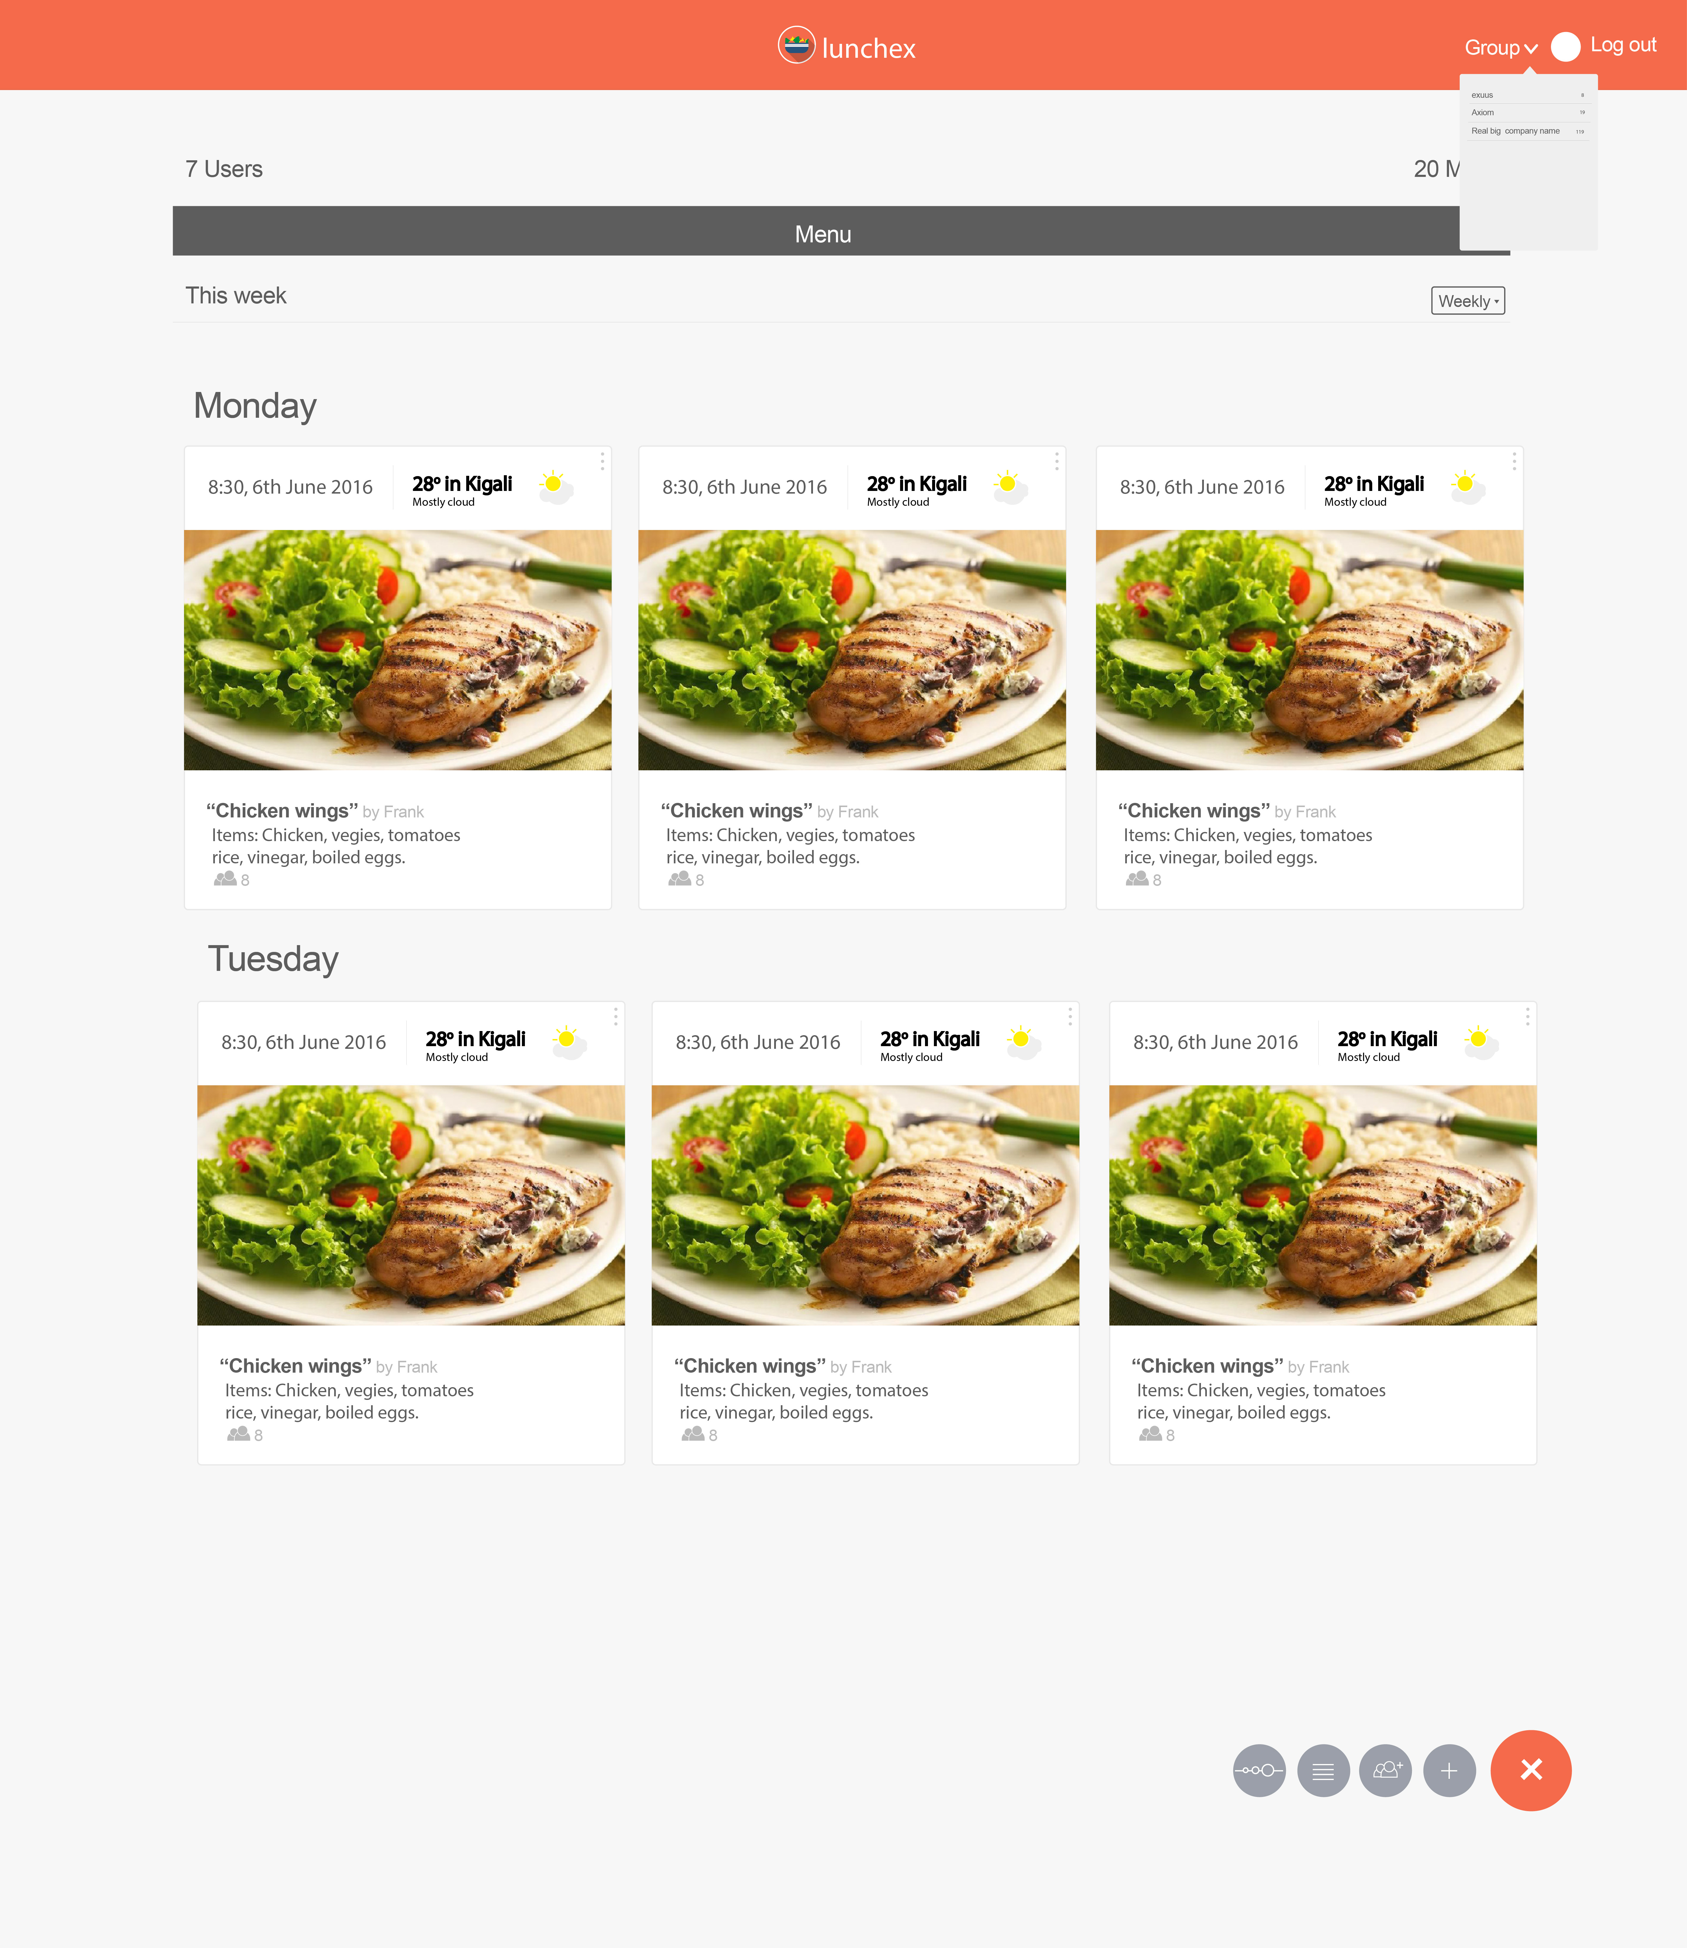

Fig 14: List of menus created by a user who is logged in.

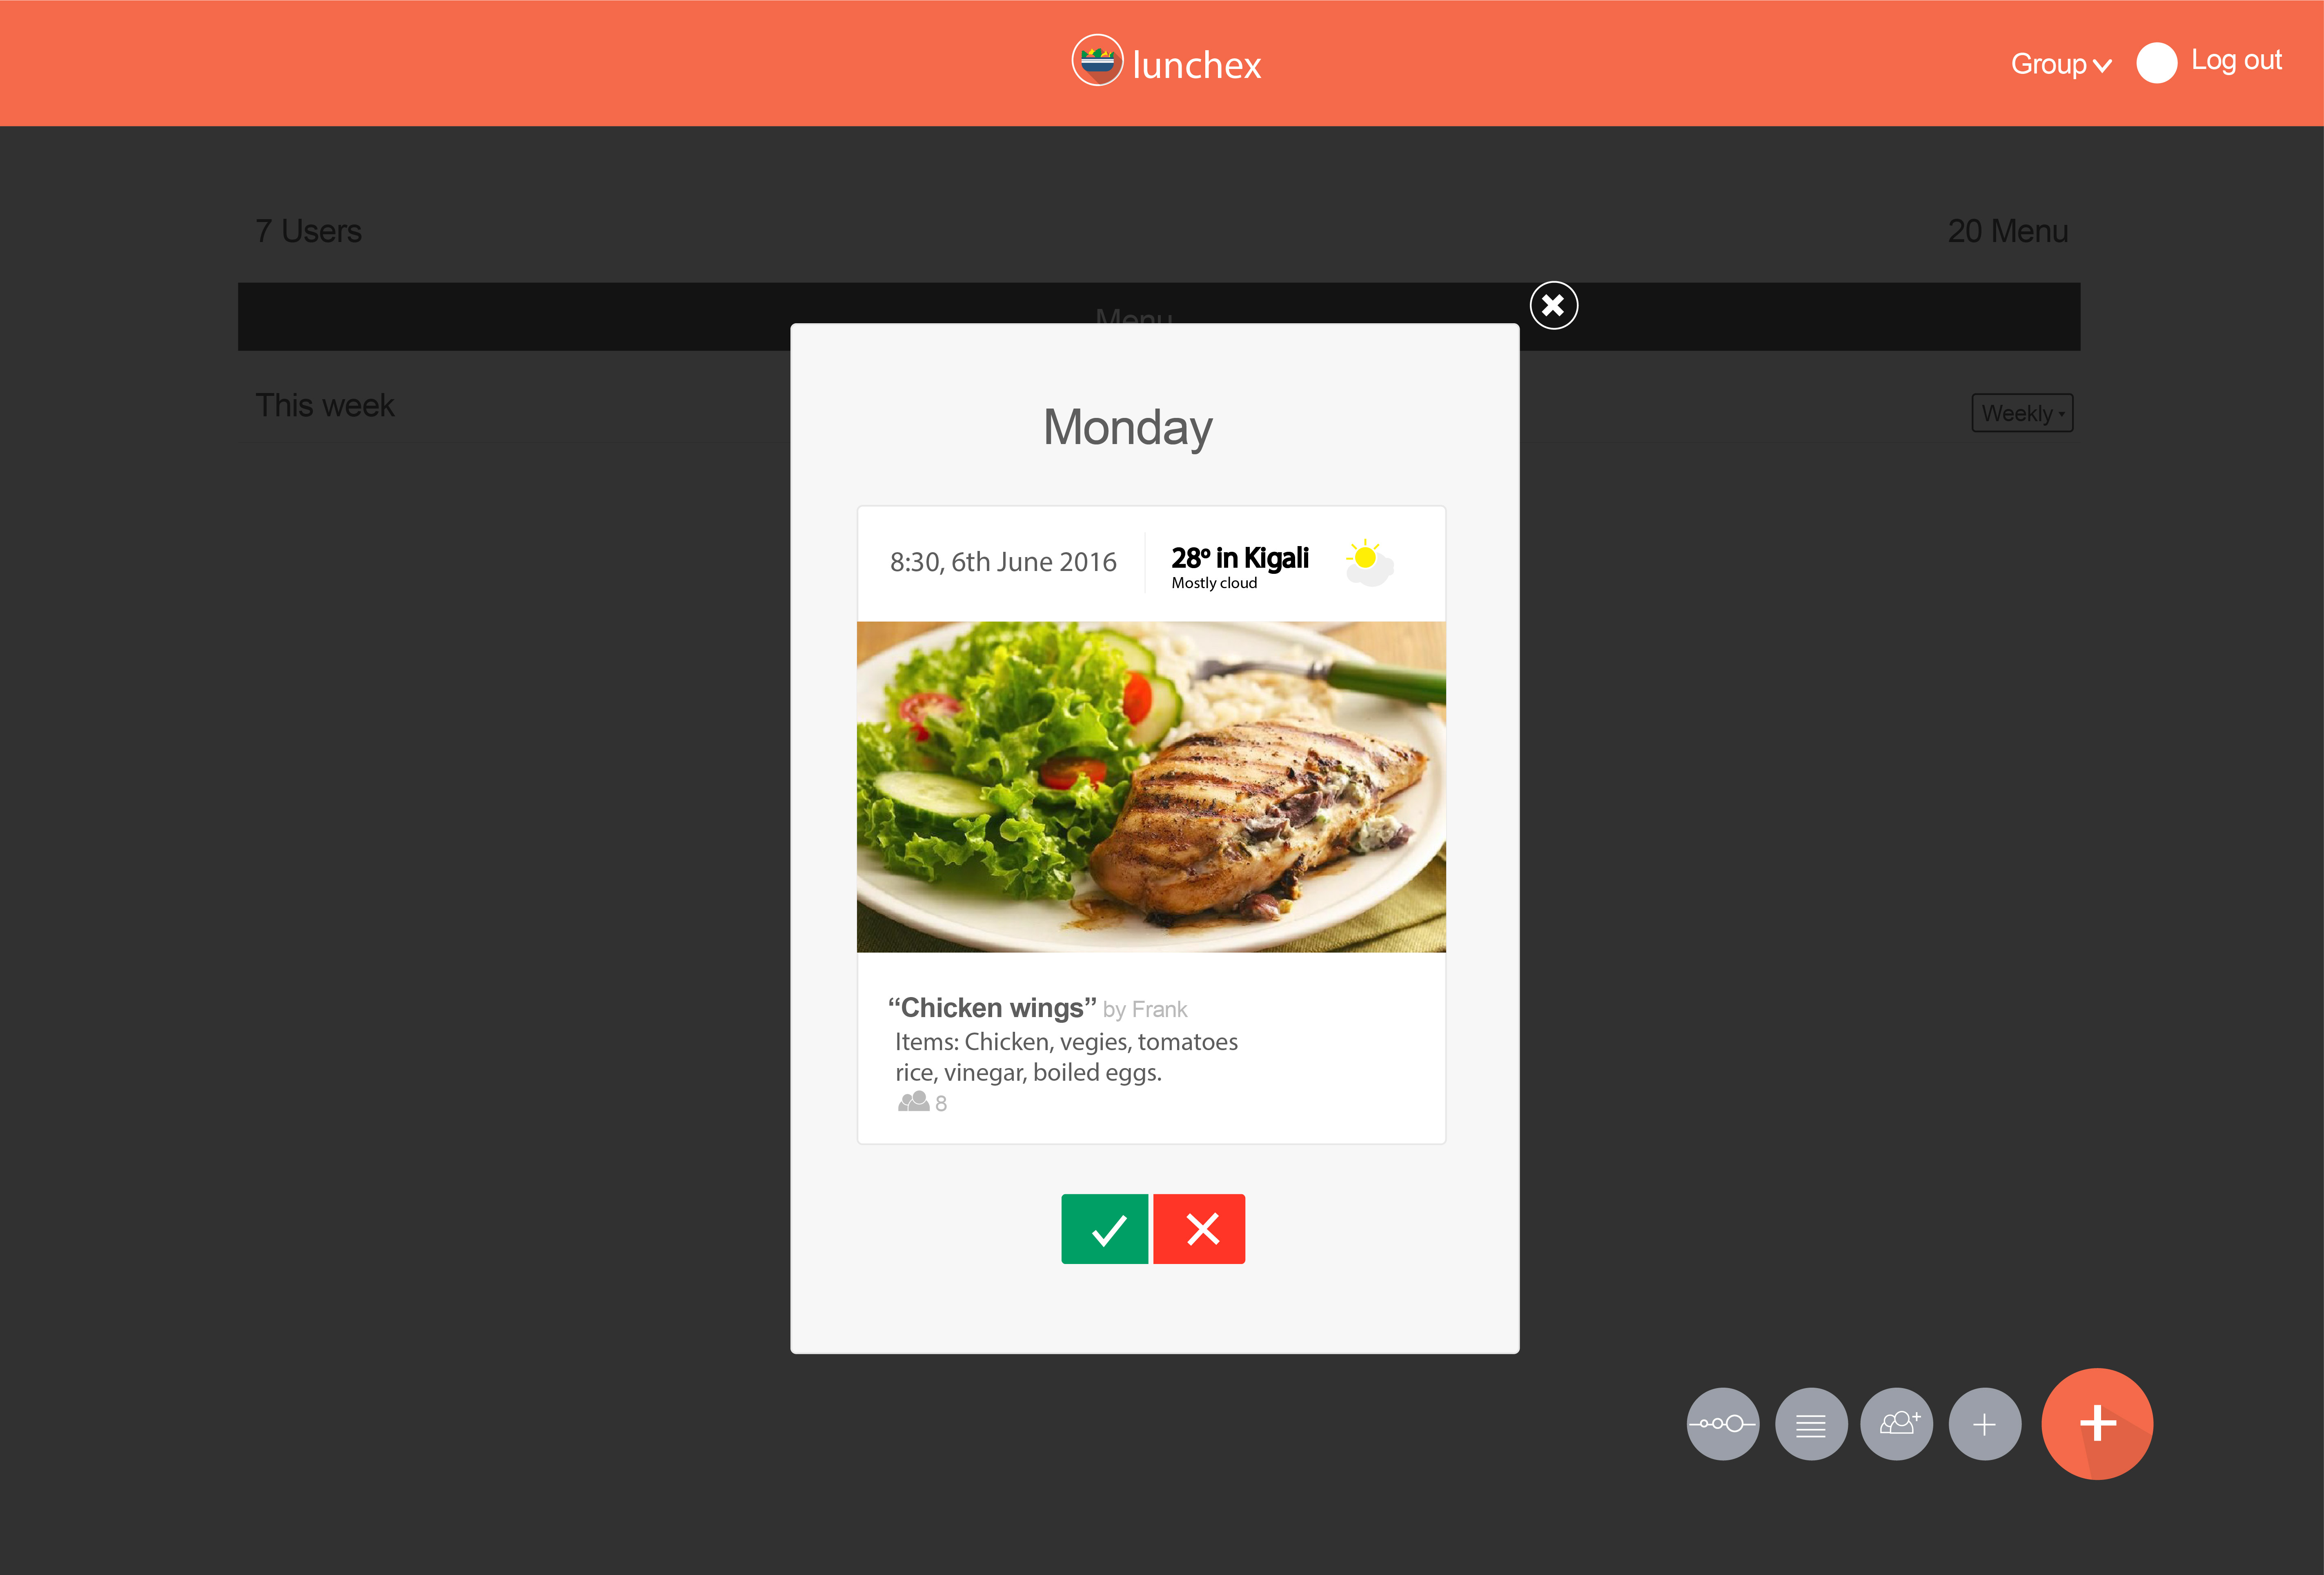

Fig 15: This is an interface where the user will confirm if he will attend or not.

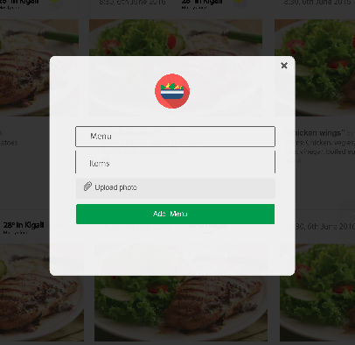

Fig 16: Interface of creating a menu,a user inserts its name,composant items and upload menu image.

3.3.4.1.2. Android Interfaces

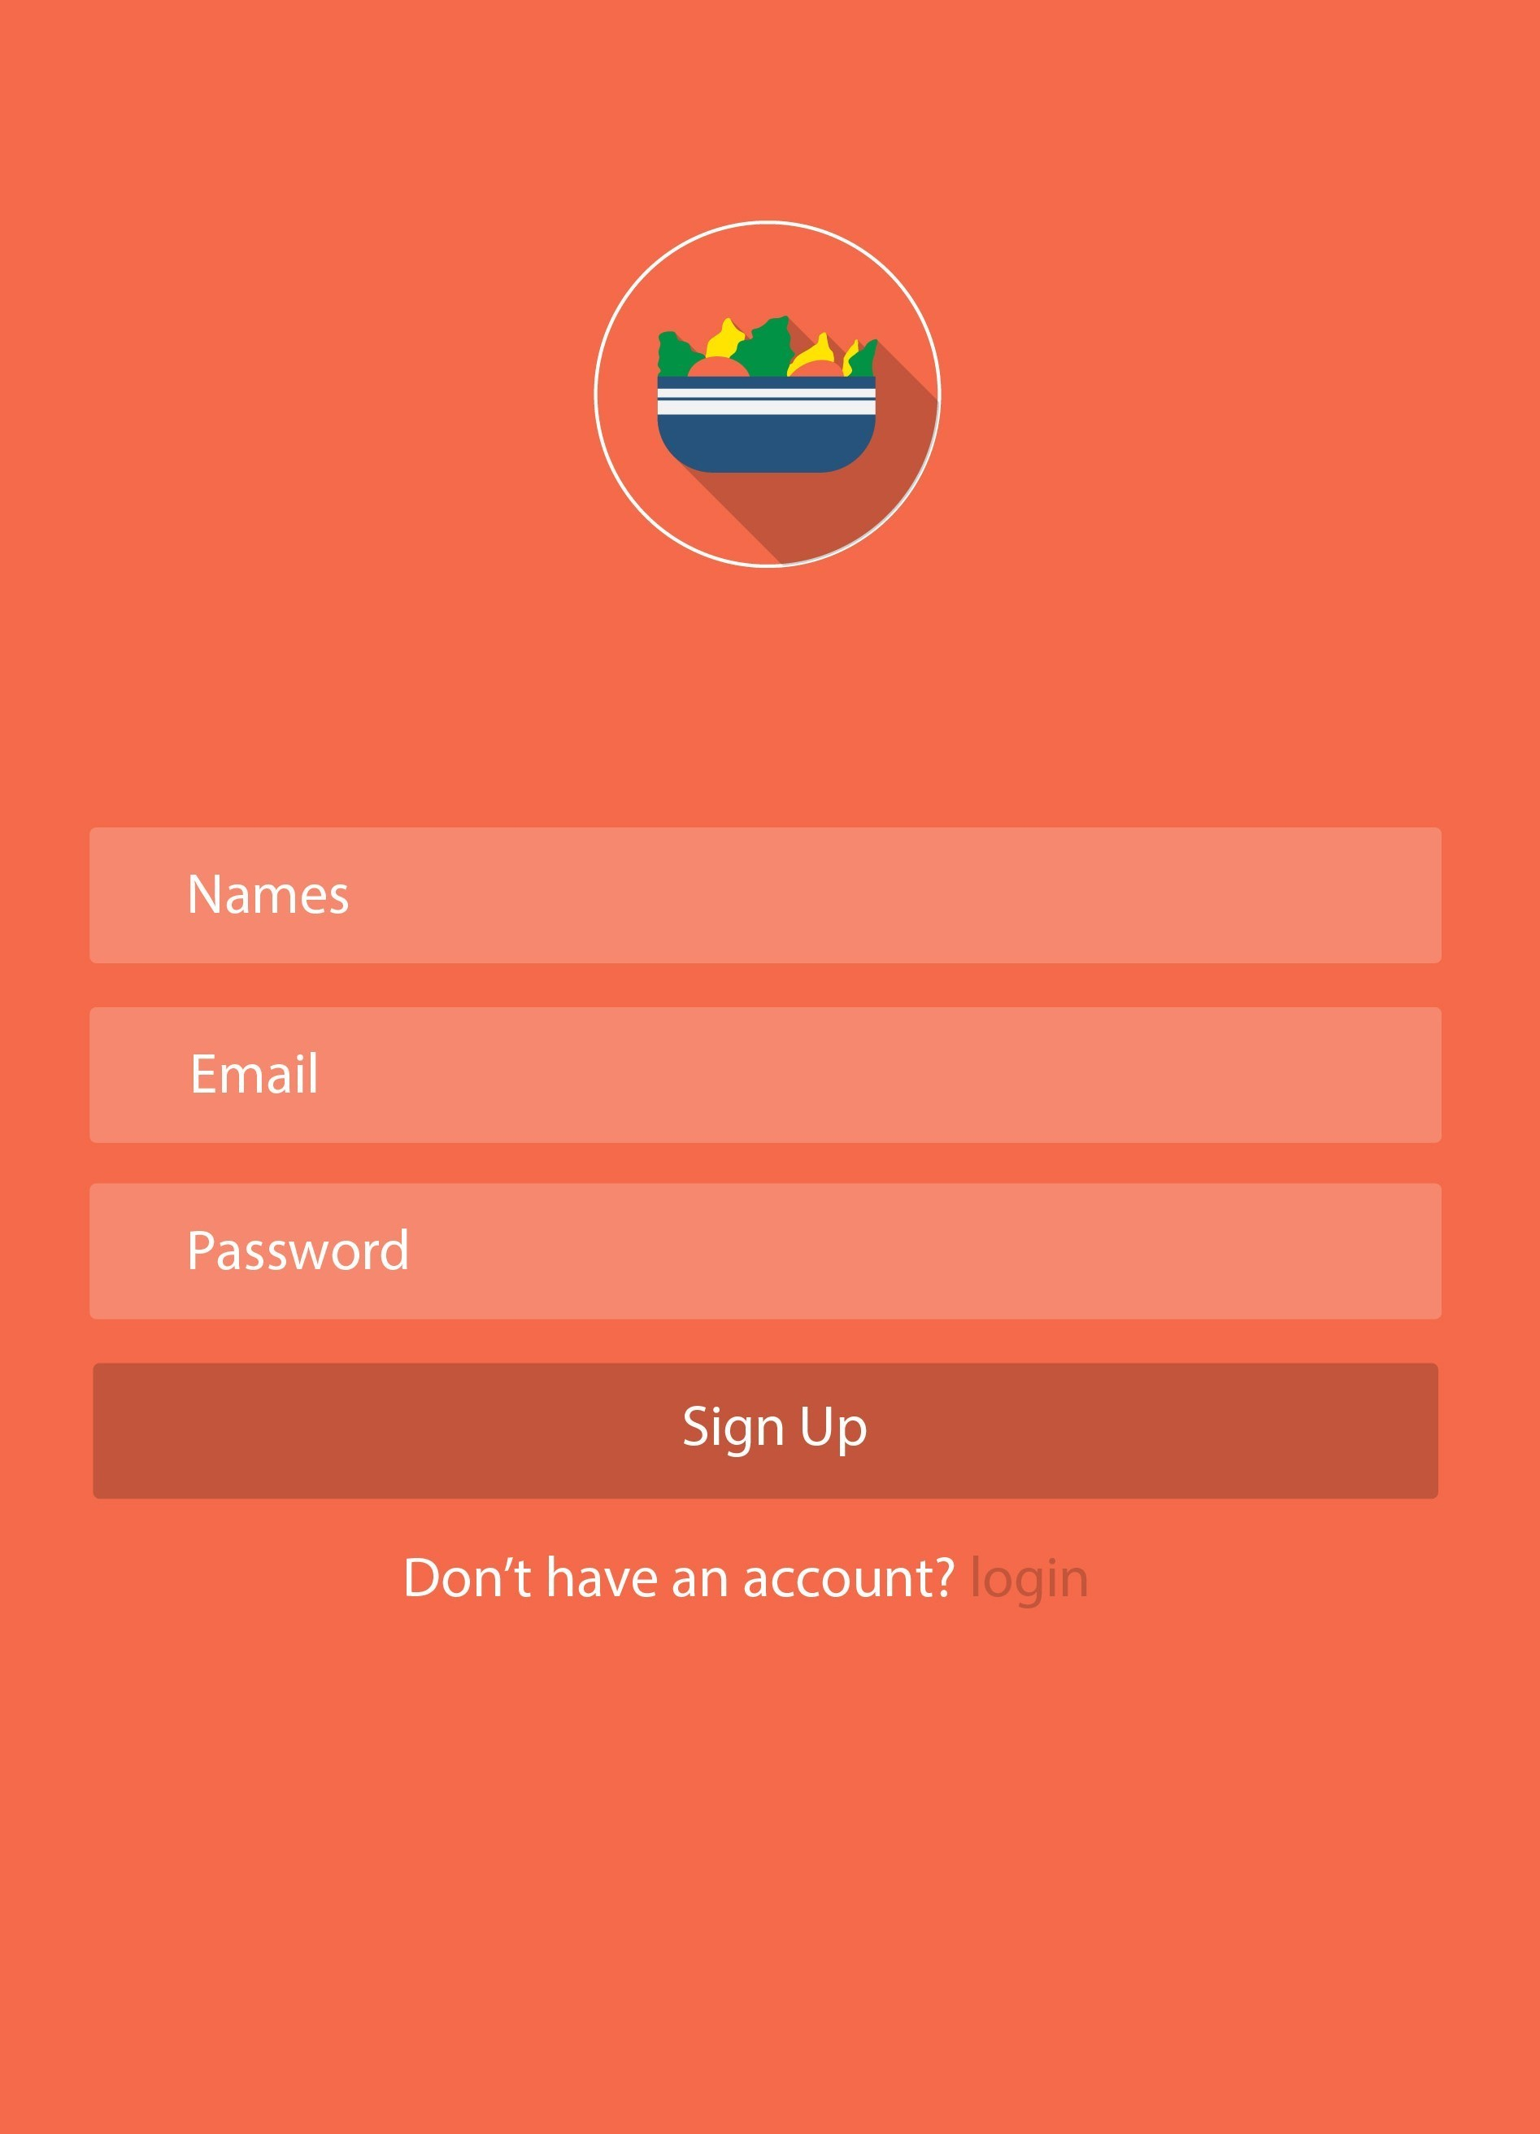

Fig 17: Android sign up interface



Fig 18: Android shared menu, and create group and create menu button

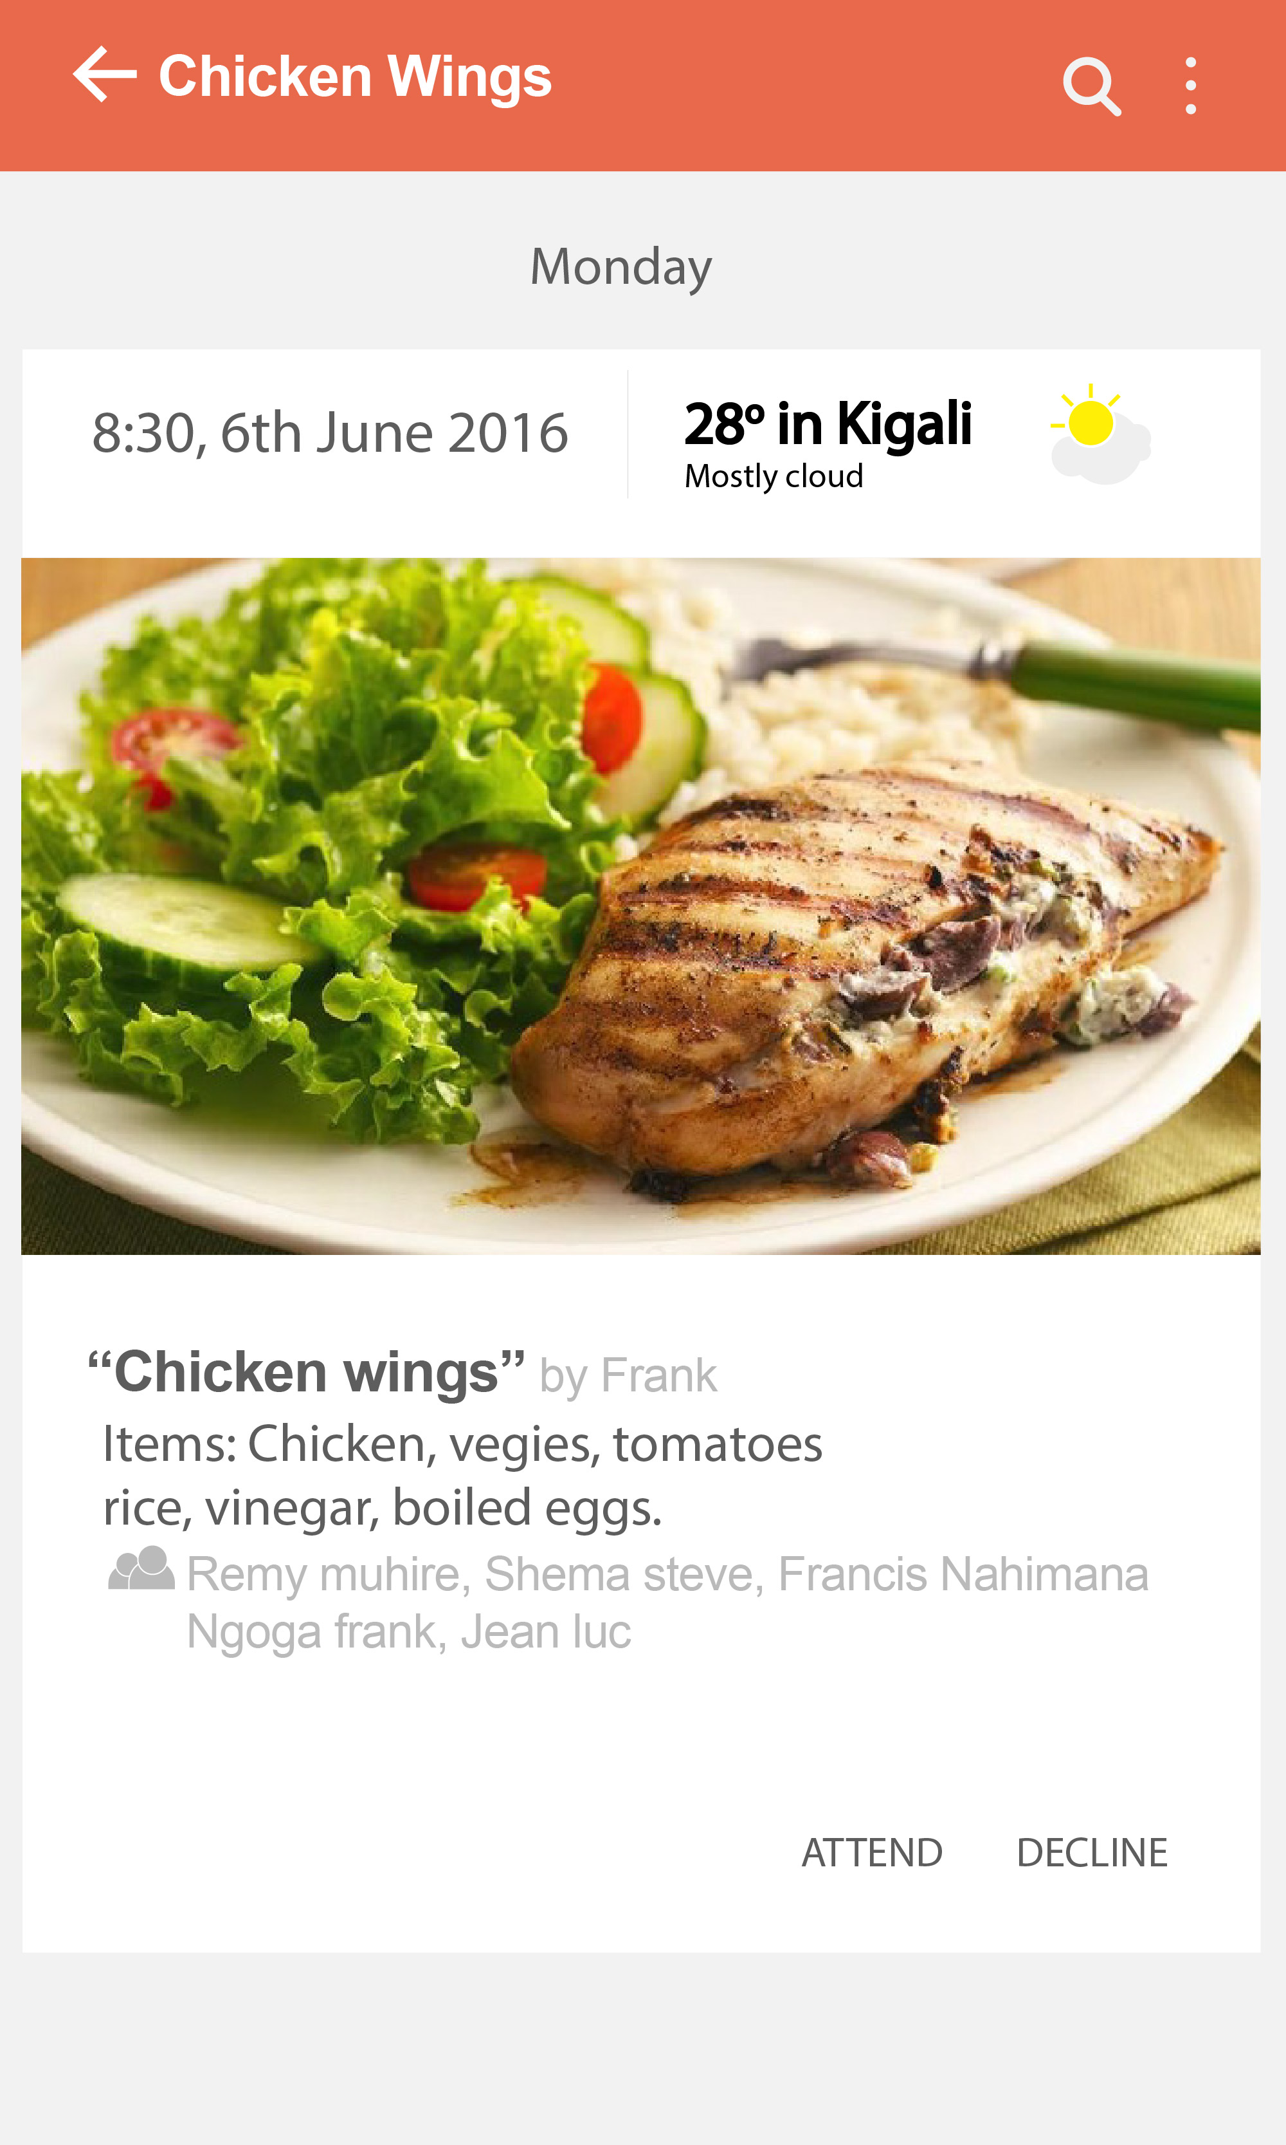

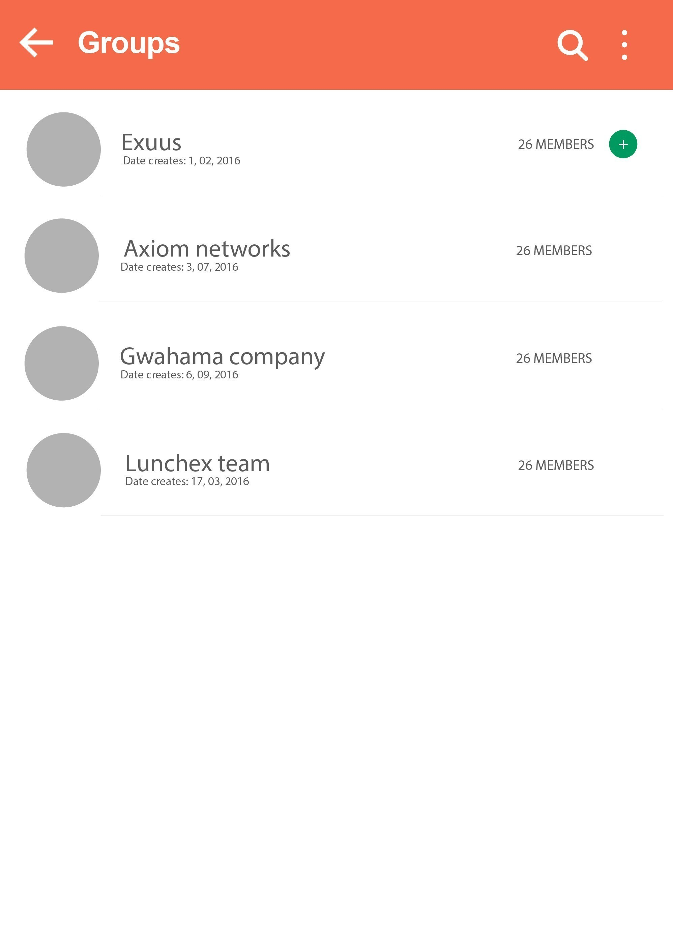 Fig 19: Android interface to confirm if a user will attend the lunch or not.

Fig 20: The interface showing the groups in which the user belongs to.

3.3.4.2 Back-end Development

The back-end Development comprises two parts: core coding part and the database.

Codes of Lunchex are developed in **Python** with its framework called **Flask** and the dbms used is **PostgreSQL.**

You may wonder how the python codes could interact with html,css and javascript of the web interface

or how they interact with android app, their linkage is done through integration where the APIs developed in Python are called on interfaces and Lunchex's integration is done using **Jquery.**

3.3.4.2.1 Database Design

Lunchex Database Tables:

1.

|  |
| --- |
| User |
| Id integer -primary key, auto-generated  fullname String  username String  birthdate Date  password String  email String  phone String  regDate Date |

A table of users was made of 8 attributes ,

* id : is autogenerated upon the creation,
* fullname: is a set of names of the user
* username: is extracted from the email i.e the first part of the email was concatenated then this part becomes the username,
* birthdate: is a birth date of the user
* password: is a string
* email: is string , it has to be valid and unique email address,
* phone: is astring it has to be valid and unique,
* regDate is a registration date which is got from the system.

2.

|  |
| --- |
| Group |
| Id Integer -primary key, auto-generated  name String  members String  admin Integer  regDate Date |

A table of groups was made of 5 attributes,

* ID: is integer and auto-generated upon the group creation,
* name: is a string and it is the name of the group
* members: is a string of ids of people in the group. Eg: 1,3,5,7,9. This ids are got from the users table, regDate : creation date.

3.

|  |
| --- |
| Menu |
| Id Integer -primary key, auto-generated  name String  items String  image String  regDate Date  creator Integer -foreign key (User, user-id) |

A table of menus was made of 6 attributes, this is a table of all menus created. It is made of :

* id is auto-generated upon menu creation,
* name is a string and it is the name of the menu
* items is a string of items composing the menu,
* image: this is a string of path of the image on the server,
* regDate: creation date,
* creator: this is an Id of the user who created the menu.

4.

|  |
| --- |
| Sharings |
| Id Integer -primary key, auto-generated  lunchTime Date  participants String  group_id Integer -foreign key (Group, group_id)  menu_id Integer -foreign key (Menu, menu_id)  regDate Date |

A table of sharings is made of 7 attributes:

* Id: integer - primary key , auto-generated
* lunchTime: This is an attribute showing the time to be served.
* Participants: String of ids of people who confirmed to attend e.g: 1,7,4,5.
* Group_id : A foreign key from the group table and it shows the id of the group where the sharing is.
* Menu_id : A foreign key from the menu table and it shows the id of the menu shared to the group.

5.

|  |
| --- |
| Cover |
| Id Integer -primary key  user_id Integer -foreign key (User, user id)  code Integer |

A table of cover is used in password recovery it holds the last used codes in reovering.

**3.3.5. Coding**

As mentioned above, the front end part was done in HTML,CSS, Javascript alongside Bootstrap framework for much better designs. So, The backend coding of Lunchex was done in Python using its framework called: “Flask”.

3.3.5.1. Tools used in the process of Development:

Atom: Integrated Development Environment(IDE), it is the one I used in writing codes.

Terminal : To test and install needed python packages.

Github : for code sharing and versions management.

Trello : Keeping track of activities and checklisting.

Slack: Communication with the team.

Google Chrome, Mozilla Firefox : Internet Browsers.

Shotwell viewer : Image editing.

3.3.5.2. Creation of tables and techniques of querying

The first step was to create a database and it was created in postgreSQL. The creation of tables of tables was done according to classes. Flask allows you to connect to your database and by flask-migrate which is an extension of Flask you can create a file of classes and from this file you migrate those classes and by default each class becomes a table and its attributes become fields of that table , this flask migrate is efficient in the creation of your tables, because sometimes when tables are created apart and class apart you may find some errors like maybe a field which is in the table but not in class or an attribute of class which was not created in the table of the database.

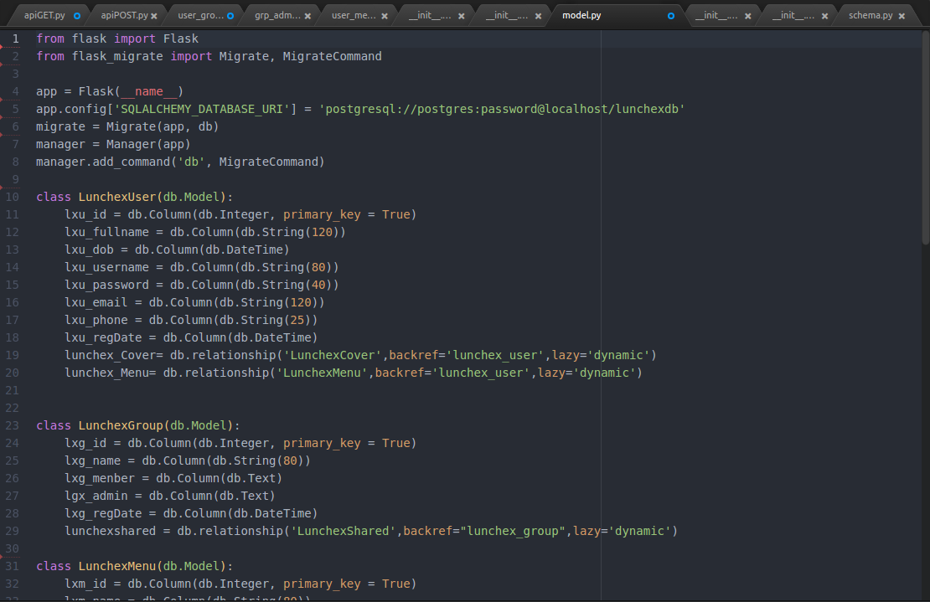

Fig 21: A screenshot showing “the model.py”, a file containing classes and connection of lunchex

database.

The querying process is directed by Sqlalchemy which is the Python SQL toolkit and Object Relational Mapper that gives application developers the full power and flexibility of SQL.

Flask-SQLAlchemy is an extension for Flask that adds support for SQLalchemy to your application. It requires SQLAlchemy 0.6 or higher. It aims to simplify using SQLAlchemy with Flask by providing useful defaults and extra helpers that make it easier to accomplish common tasks.

3.3.5.3 . Developing APIs

APIs were developed as linkage between the data in database and interface; The querying is done using SQLalchemy and the results are converted into JSON (Javascript Object Notation) and it is displayed on the interface through an HTTP request, Lunchex integration was done using Jquery.

## **1.What is REST ?**

## REST stands for **Re**presentational **S**tate **T**ransfer. REST is web standards based architecture and uses HTTP Protocol for data communication. It revolves around resource where every component is a resource and a resource is accessed by a common interface using HTTP standard methods. REST was first introduced by Roy Fielding in 2000.

In REST architecture, a REST Server simply provides access to resources and REST client accesses and presents the resources. Here each resource is identified by URIs/ global IDs. REST uses various representations to represent a resource like text, JSON and XML. Now a days JSON is the most popular format being used in web services.

## HTTP Methods

Following well known HTTP methods are commonly used in REST based architecture.

* **GET**- Provides a read only access to a resource.
* **POST**- Used to create a new resource.
* **DELETE**- Used to remove a resource.
* **PUT**- Used to update a existing resource or create a new resource.

**2.Lunchex GET APIs**

The Lunchex Get APIs were the ones of:

-Getting users

-Getting groups

-Getting menus

-Getting sharings

-Getting sharing in a group

-Getting group members

-Getting group admin

-Getting menu creator

-Getting shares in a particular group over a particular period

-Getting the daily shared menu

-Getting the last seven days shares in a particular group,….

When a request is sent, the query is done through the database by SQLalchemy and the schema of the class is used to serialize the results and then JSONify them and this serialization is facilitated by a falsk extension called flask-marshmallow.

Flask-Marshmallow is a thin integration layer for [Flask](http://flask.pocoo.org/) (a Python web framework) and [marshmallow](http://marshmallow.readthedocs.io/) (an object serialization/deserialization library) that adds additional features to marshmallow, including URL and Hyperlinks fields for HATEOAS-ready APIs. It also (optionally) integrates with [Flask-SQLAlchemy](http://flask-sqlalchemy.pocoo.org/).

The Python ecosystem has many great libraries for data formatting and schema validation.

In fact, marshmallow was influenced by a number of these libraries. Marshmallow is inspired by[Django REST Framework](http://www.django-rest-framework.org/),[Flask-RESTful](http://flask-restful.readthedocs.io/), and [colander](http://docs.pylonsproject.org/projects/colander/en/latest/). It borrows a number of implementation and design ideas from these libraries to create a flexible and productive solution for marshalling, unmarshalling, and validating data.

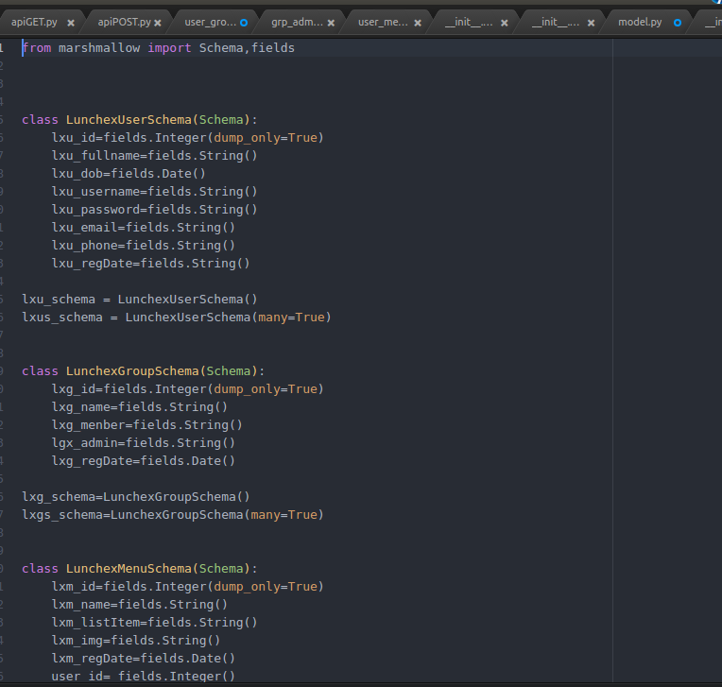

Fig 22: A screenshot showing the schema of marshmallow which use classes.

Examples of GET Apis:

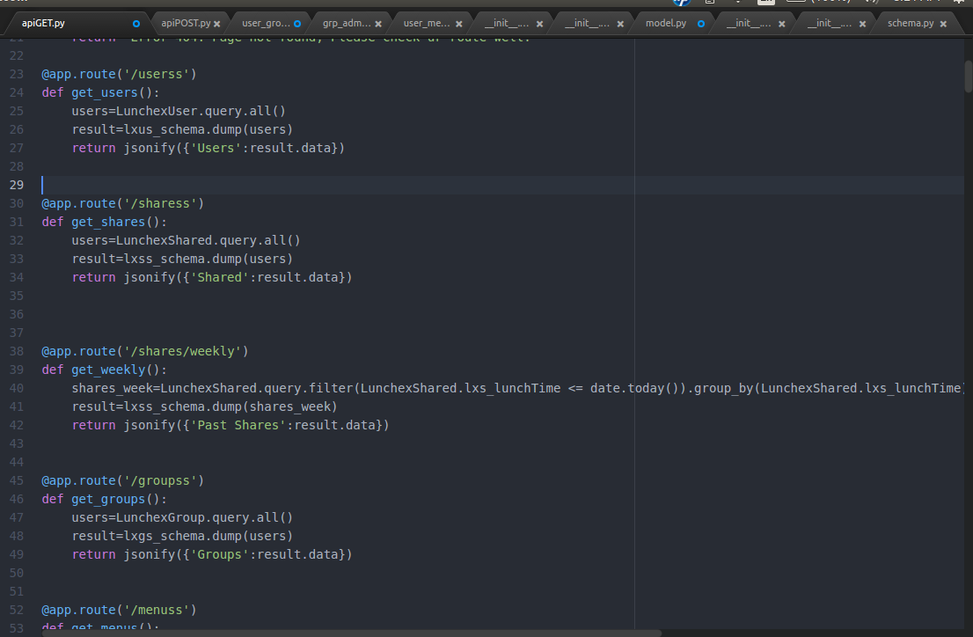

Fig 23: A screenshot showing the GET API of querying all users, groups,menus , the querying is done using sqlalchemy.

Let's go in details one among these . e.g: /userss

@app.route: app is the name of the my application.

('/userss', methods=''GET'') : this is the route the HTTP reuqest will be following after the IP and the Port, this is the route to follow and it shows that it is a GET method.

def get_users(): Declaring the function

users = LunchexUser.query.all() : the declared “users” is an object hold the result of the query, LunchexUser is the class of users which by migration it was created as a table in the database and the next is “query” a sqlalchemy property of querying and then “all()” which shows that it's selecting all

result = lxus_schema.dump(users) : “result” is the serialized reslut of the “users” object and this serialized object is the one which can be jsonified which is done on the next line.

Return jsonify({''users'': result.data}) : this is what is returned by this function. It is a jsonified result which is returned and sent back to the interface, once a request is made on this route, this is the result that will be gotten.

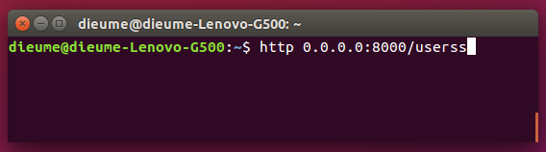

Fig 24: A screenshot showing the http request , 0.0.0.0: this is the IP, 8000 : is the port and /userss is the route.

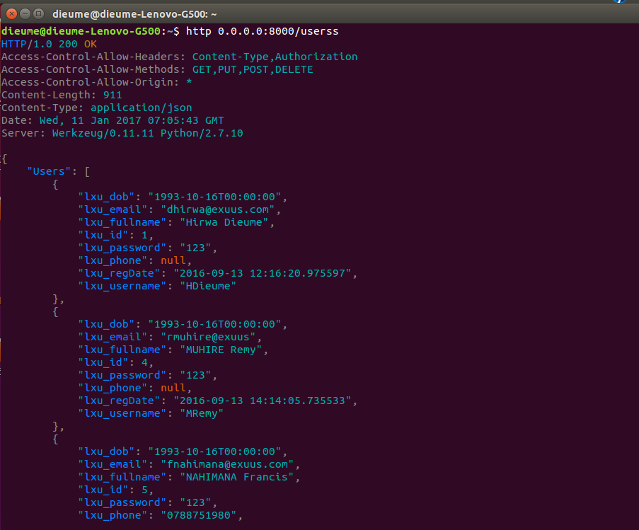

Fig 25: This is the result of the query a json generated by the request we made above.

**3. Lunchex POST APIs:**

POST Apis were sending data to the database to be saved there:

These included APIs to:

* sign up
* sign in
* create a group
* create a menu
* sharing a menu in a group

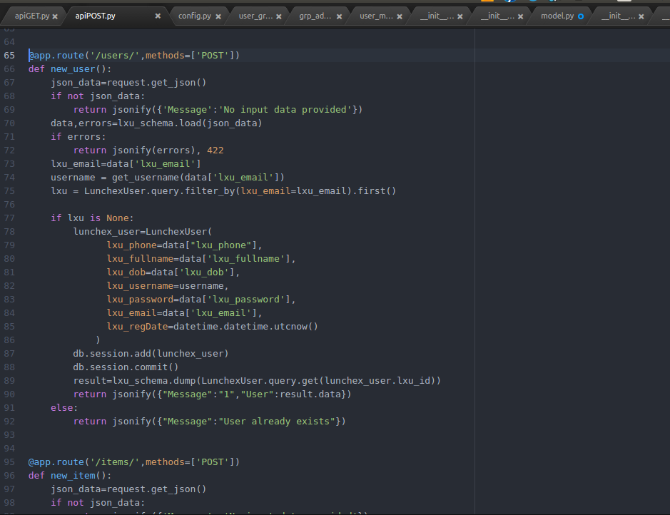

Fig 26: A screenshot of POSTING or creating a new user.

* @app.route: this shows the route and that the method is post
* def new_user(): the function
* json_data = request.get_json() : the data come in Json format so this is for checking if there are data in that json.
* data= lxu_schema.load(json_data) : this is loading the json data, the schema is deserializing them so that they can be read in flask , they will be read under an object called “data”
* username = getusername(“data[lxu_email]”) : this is a function which extracts the first part of the email and assigns it to the username value.
* lxu = LunchexUser.query.filter_by(lxu_email=lxu_email).first() : as the email is a unique attribute, this line is for checking if there is no other user with the same email.
* if lxu is None: this is an if of what will happen once there is no other user with the same email.
* lunchex_user=LunchexUser(
* lxu_phone=data["lxu_phone"],
* lxu_fullname=data['lxu_fullname'],
* lxu_dob=data['lxu_dob'],
* lxu_username=username,
* lxu_password=data['lxu_password'],
* lxu_email=data['lxu_email'],
* lxu_regDate=datetime.datetime.utcnow()
* ) : Here, we are assigning the class attributes each to its json_data correspondent, remember with sqlalchemy we can use this class of ours to save in the database.
* db.session.add(lunchex_user) , db.session.commit() : Both of the lines are for saving in the database under table LunchexUser.
* result=lxu_schema.dump(LunchexUser.query.get(lunchex_user.lxu_id))
* return jsonify({"Message":"1","User":result.data}) : this is for displaying the user saved.

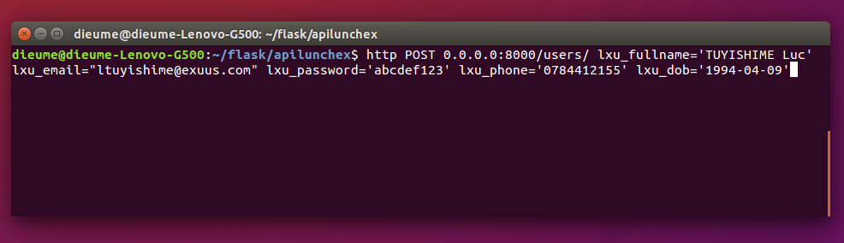Fig 27: Screenshot of sending the request POST the user Luc., this is the same flow of data that is posted once you click on “Sign up ” on **fig: 12.**

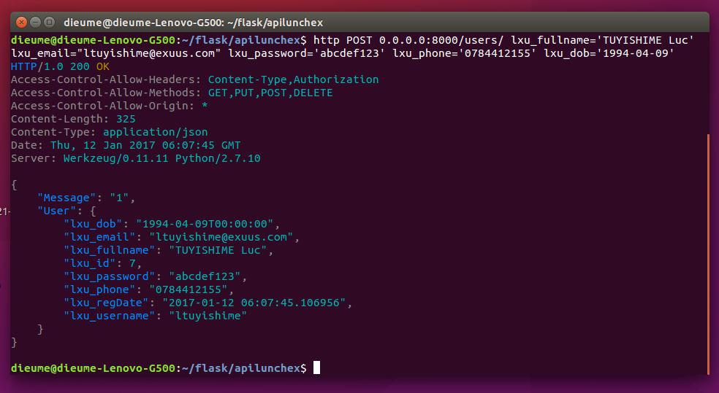

Fig 28: This is the result which will be got when we post “Luc Tuyishime”,

**4. Lunchex PUSH Apis:**

Push: this is used for Updating.

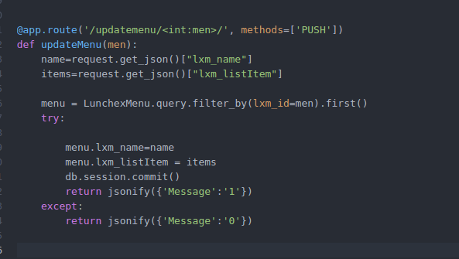

Fig 29: this is an API of updating a menu, you can update its name and items composing it.

**5. Lunchex DELETE APIs:**

This is an API of deleting what you want to remove in the database.

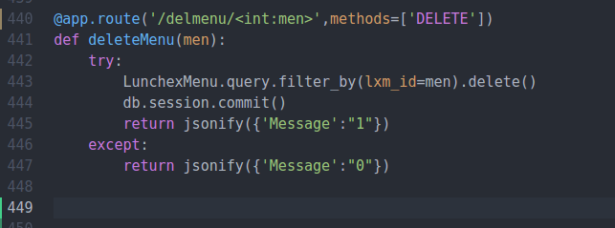

Fig 30: this is an API that deletes a menu according to its ID , You pass the id to it and it deletes that specific menu.

**3.3.6. Conclusion**

Lunchex beta version was released but after sometimes it was stopped, it's a released app but not in use for now, after some improvements it will released.

But there is of its beta version on google play store : <https://play.google.com/store/apps/details?id=com.exuus.lunchex&ah=MbEZPAGCe2ZEYFe4HiAYhiIh27s>

# CHAPTER FOUR: APPRECIATIONS, CONCLUSION AND RECOMMANDATIOS

# 4.1. Appreciations

# I appreciate the warm welcome I was given by EXUUS ltd especially the technical and development team, I really appreciate the cooperation, togetherness and the discipline exhibited during the whole course of my industrial training program by EXUUS ltd staff.

# 4.2. Conclusion

This industrial training , did not equip me with the necessary knowledge required for academic progress only , but it also helped me in database knowledge , software development life cycle, useful tools in software development, user interface and user experience knowledge too. In EXUUS ltd, I also learnt a lot of new technologies. This was attained through interaction with EXUUS ltd staff members through various discussions. Objective of conducting internship was to practice what I learnt in class and it was very amazing to me because I entered in EXUUS ltd ,they have welcomed me and they have given me the needed package.

# 4.3. Recommendations

# 4.3.1To the organization (EXUUS ltd)

EXUUS ltd should continue to provide internship opportunities to students, because it is very helpful to them and to the development of our country.

# 4.3.2. To the university

I would like to request the AUCA administration to improve their partnership with companies to help students get the internship where they can get more skills and not only in the period of internship allow students to visit those companies related to their career during their study time, and in addition to this invite them in public lectures to share their experience with students so that students will gain more and help them to become entrepreneurs.

I also recommend my fellow students to get their training from EXUUS ltd.because, I learnt what I wanted.

**CHAPTER FIVE: REFERENCES**

**Electronic sources**

* [www.exuus.com](http://www.exuus.com/)
* [www.google.com](http://www.google.com/)
* [www.w3schools.com](http://www.w3schools.com/)
* <http://flask.pocoo.org/>
* [www.stackoverflow.com](http://www.stackoverflow.com/)